Summer 2015
Science Adventures
Santa Monica Pier Aquarium

Topics for WEEK 1: June 22nd – June 26th (K-1st)

MAGNIFICENT MONDAY: The biggest and fastest animals live in the Open Ocean habitat where different marine species compete for food and space to live. Come learn about these wonderful animals from whales to sharks to turtles, oh my!

TOO KELPY TUESDAY: Let’s explore one of the most diverse and fastest growing places in our ocean, the Kelp Forest. We will learn that animals need this habitat to survive, and how people can be Kelper Helpers to this wonderful habitat.

SIMPLY SANDY WEDNESDAY: Sand, sand, and more sand! The Sandy Bottom and Sandy Shore are amazing places to visit as animals could be living right under our feet. We will investigate our local sandy shore and see what we can dig up.

ROCKIN’AND ROLLIN’ THURSDAY: Life in the Rocky Shore habitat definitely has its ups and downs with waves, that is. Through role-playing games we will learn how animals survive in this environment.

FRIGHTENING FRIDAY: Our ocean is in trouble and the problem is US! Find out how trash left on our streets gets into the ocean and how it impacts our ocean friends once it is there. But best of all, find out ways we can help!

Topics for WEEK 2: July 6th – July 10th (K-1st)

MINI MONDAY: The ocean contains life both big and small. Explore the unseen side of life, plankton and how it drives our entire ocean food chain.

TOOTHY TUESDAY: Sharks! Help gnaw through the misconceptions, as we get up close and personal with these amazing animals.

WHALE OF A WEDNESDAY: Come explore the lives of the largest animals on Earth! A day full of large bones, huge teeth and big discoveries awaits.

OOEY GOEY THURSDAY: Life is not hard for these spineless creatures that call the ocean home. Meet some of the invertebrates that can be found right off our beaches.

FISHY FRIDAY: Let’s swim through the diversity of fishes as we learn about the fastest, largest and most interesting that our ocean has to offer.

Topics for WEEK 3: July 13th – July 17th (1st- 3rd)

MIDNIGHT MONDAY: Deep in the ocean, where light never goes, live strange and wonderful creatures that almost nobody knows. Explore the depths of our ocean and learn about some of our planet’s most bizarre creatures.

TRASHY TUESDAY: Our ocean is in trouble and the problem is US! Find out how trash people leave on our streets get into the ocean and what it does to our ocean friends once it is there. But best of all, find out ways we can help!

WACKY AND WONDERFUL WEDNESDAY: The ocean is a strange and wonderful place. Learn about some of our planet’s most unusual inhabitants.

THIRSTY THURSDAY: Take a journey through history about water and discover how people, past and present, explore the ocean and use water in their lives.

FROZEN FRIDAY: The poles, both North and South, are some of the toughest places to survive. Yet life thrives. Come learn about polar bears, penguins, narwhales and more!

Topics for WEEK 4: July 20th – July 24th (1st -4th)

MAGNIFICENT MONDAY: The biggest and fastest animals live in the Open Ocean habitat where different marine species compete for food and space to live. Come learn about these wonderful animals from whales to sharks to turtles, oh my!

TOO KELPY TUESDAY: Let’s explore one of the most diverse and fastest growing places in our ocean, the Kelp Forest. We will learn that animals need this habitat to survive, and how people can be Kelper Helpers to this wonderful habitat.

SIMPLY SANDY WEDNESDAY: Sand, sand, and more sand! The Sandy Bottom and Sandy Shore are amazing places to visit as animals could be living right under our feet. We will investigate our local sandy shore and see what we can dig up.

ROCKIN’AND ROLLIN’ THURSDAY: Life in the Rocky Shore habitat definitely has its ups and downs with waves, that is. Through role-playing games we will learn how animals survive in this environment.

FRIGHTENING FRIDAY: Our ocean is in trouble and the problem is US! Find out how trash left on our streets gets into the ocean and how it impacts our ocean friends once it is there. But best of all, find out ways we can help!

Topics for WEEK 5: July 27th – July 31st (2nd -5th)
MAROONED MONDAY: Learn how pirates survive on a desert island and out at sea. Then find out how ocean animals have adapted to survive in their unique environments.

SHARK BAIT TUESDAY: Sharks! Though pirates saw sharks as monsters, help gnaw through the misconceptions, as we get up close and personal with these amazing animals.

WALK THE PLANK WEDNESDAY: Take a walk down the planks of the Santa Monica Pier. We will explore the historic landmark where land meets sea and put our pirate courage to the test as we brave the rides of Pacific Park!

THAR SHE BLOWS THURSDAY: Come explore the lives of the largest animals on Earth - whales! A day full of large bones, huge teeth and big discoveries awaits.

SCALLYWAG SCAVENGER FRIDAY: Avast, matey! Our ocean is in trouble and the problem is US! Find out how trash left on our streets gets into the ocean as we follow the map to clean up trash and discover treasures.

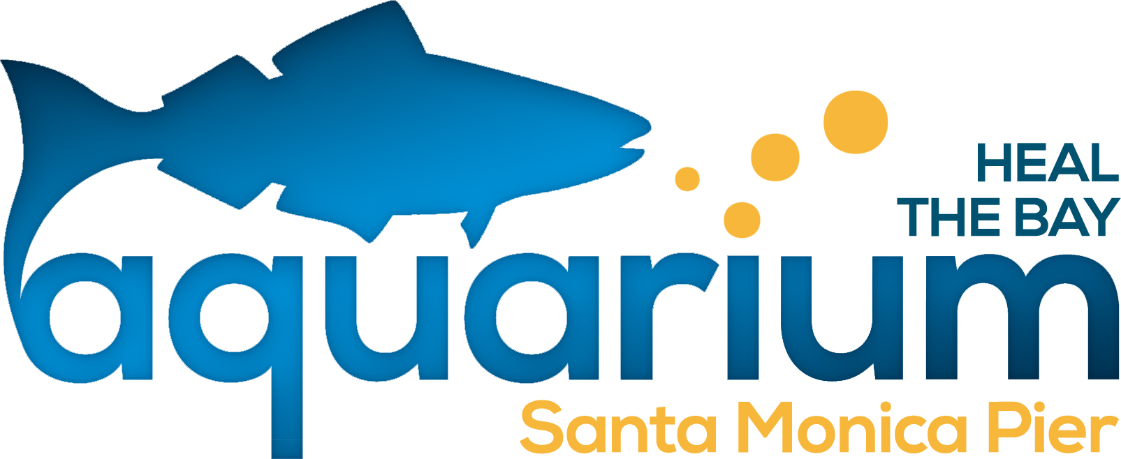
Each day the topics will be explored through games, songs, stories, crafts and laboratory experiences. Just enough science for a summer day! Camps run from 9am-2pm.

